

**Tracelay Networks**

**VULNERABILITY**

**ASSESSMENT using Rapid7 insightAppSec Platform**

Prepared for:

**Mr. Arun Dev**

Prepared by:

**Mr. Harsh Sharma**

**1. Overview**

**In this report, insightAppSec vulnerability scanner has been used to run a vulnerability assessment on web applications.**

**2. Purpose**

1. Learning Rapid7 insightAppSec Vulnerability Scanner
2. Finding Vulnerabilities in a web application

**3. Scope**

The scope of this vulnerability assessment is every route of the web application to check the vulnerability. No unethical behavior has been done during process.

**4. Platform**

**1. Rapid7 insightAppSec vulnerability scanner:** The vulnerability scanner when performed to do vulnerability assessment could find multiple vulnerability in some duration.

Automation of different attacks is performed against the web application

Platform Insights

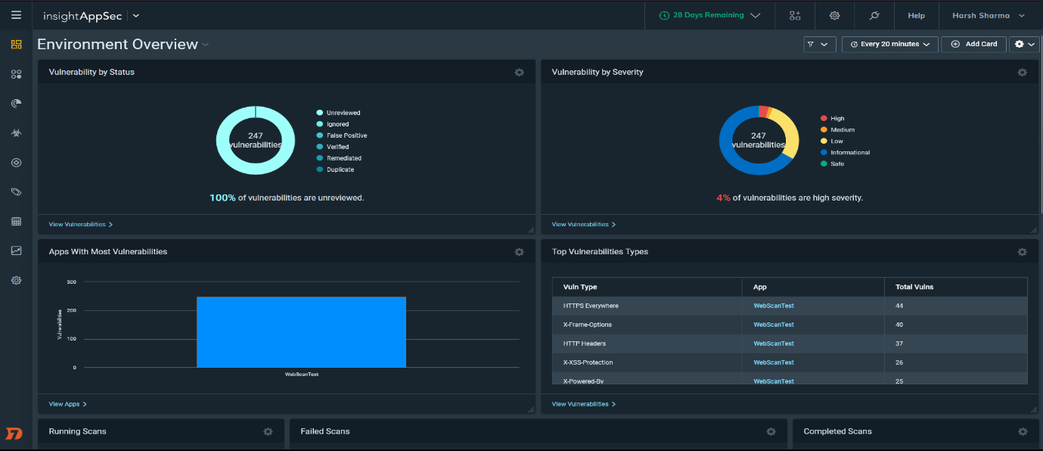

insightAppSec contains different types of functions such as scan scheduling, vulnerability detailing, scan validation etc.



**5.** Adding a web application for the scanning

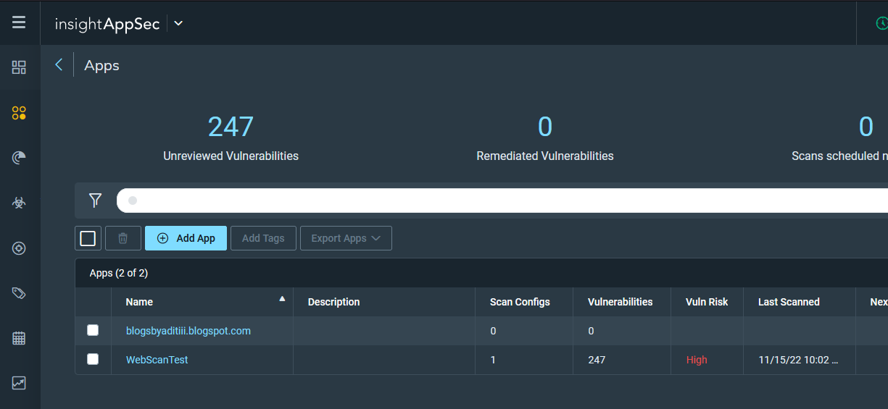

Click on app option and then click “Add App”

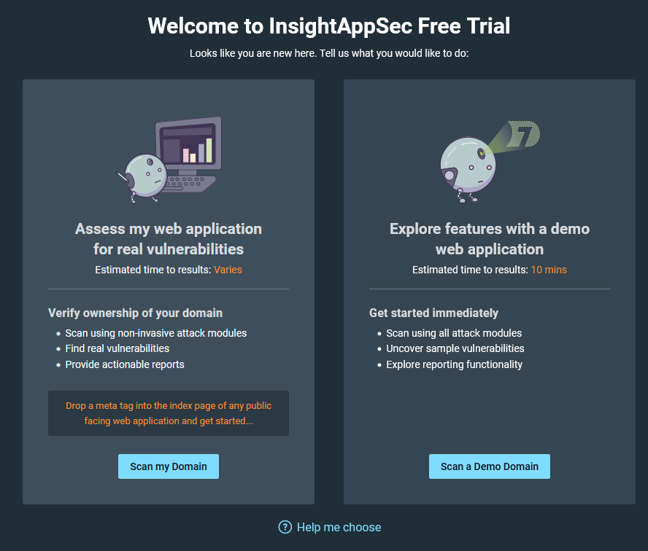

If you have your own web-app for performing vulnerability scanning, here we are scanning a demo domain. 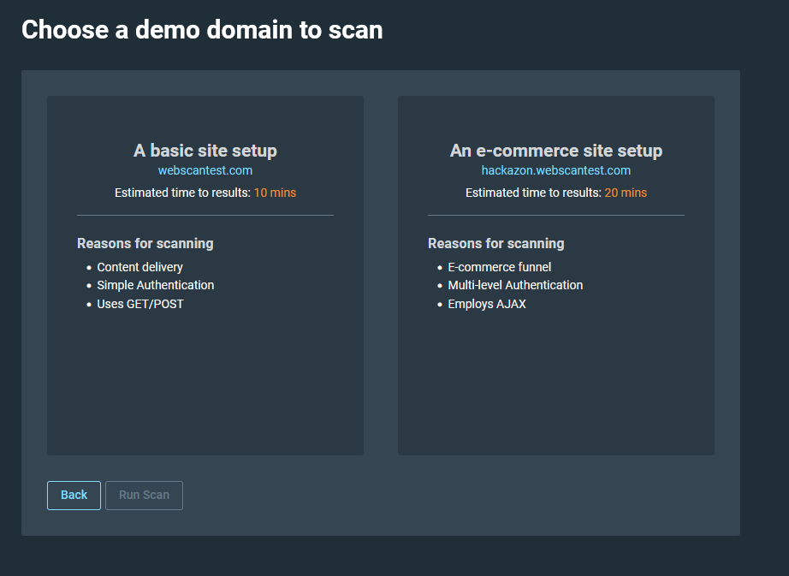

Select any from the above, here we are selecting e-commerce site and clicking Run Scan.

This will take some time to run a scan 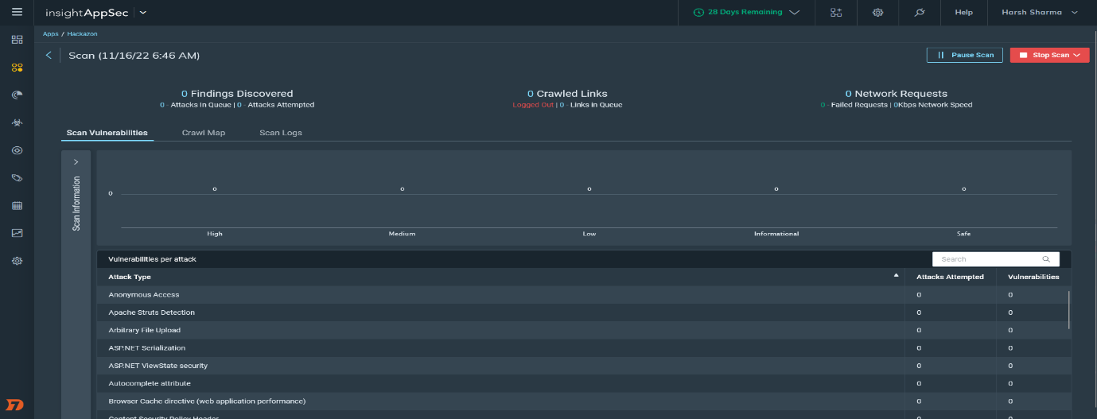

1. Scanning is now started and will take time to make network requests.

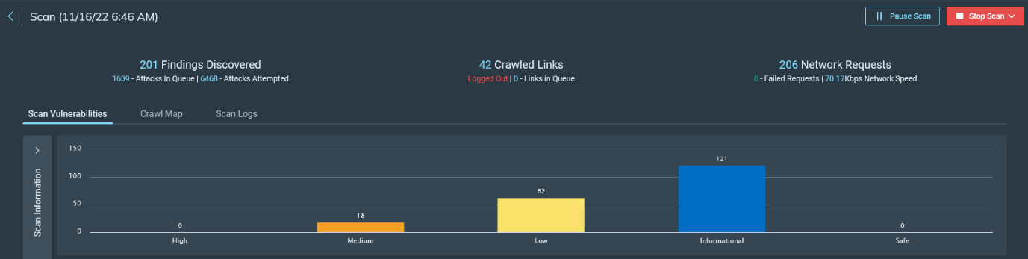

1. Here we can see some vulnerabilities with level of the severity
2. Here finding discovered refers to “vulnerabilities found”
3. Crawled Links are links scanned by the scanner
4. Network requests are all the requests made by the scanner with attacks.

**Click on Stop Scan (Stop and Keep Results) to check the vulnerabilities and analysis.**

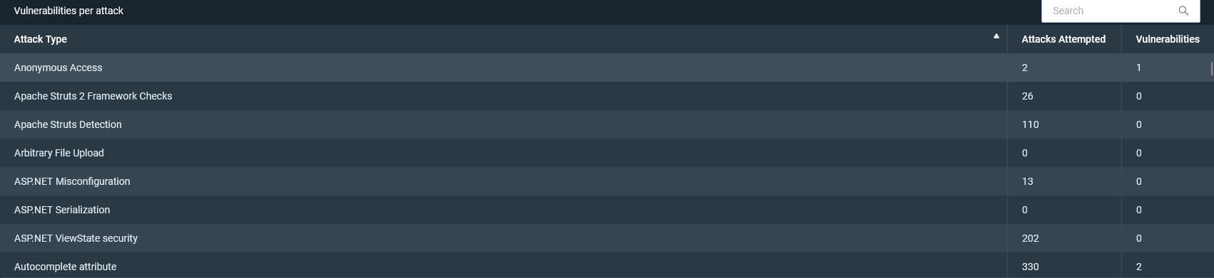

Scroll over the vulnerabilities to see the vulnerabilities found and no of attacks performed according to the vulnerabilities.

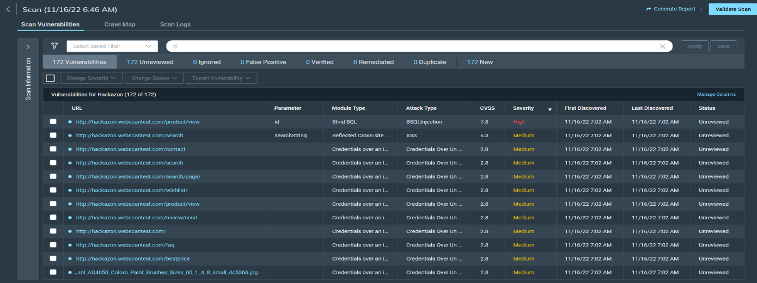

Click on any vulnerability to check the details, let us see the vulnerability with high severity

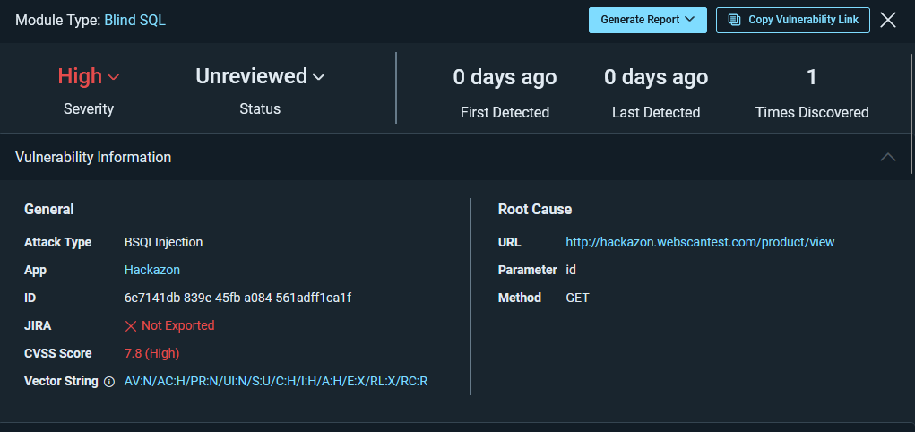To generate the whole report of vulnerability assessment, click on the generate report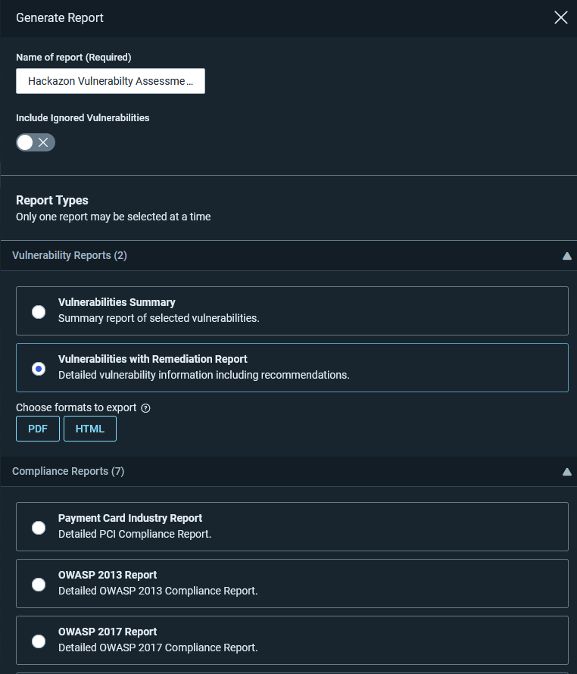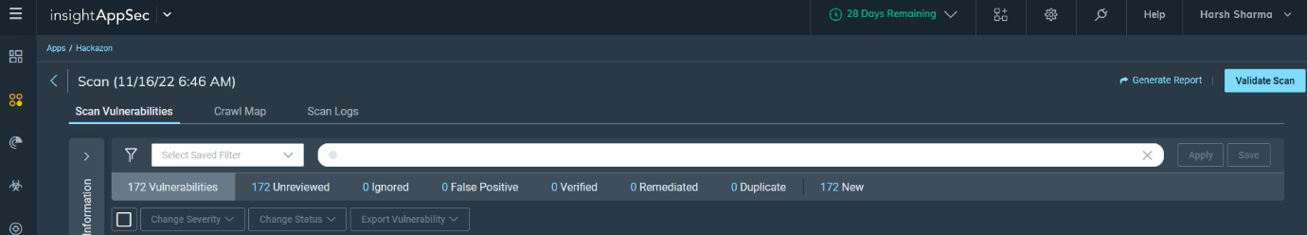

Click on “Vulnerability with Remediation Report” and click on pdf.

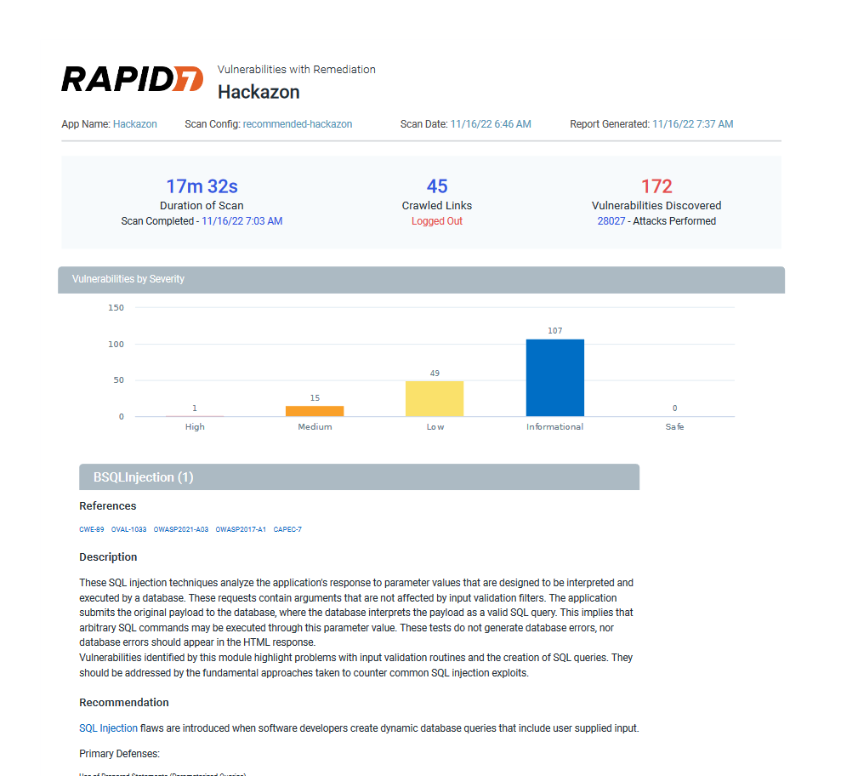

Here is the detailed report of the vulnerabilities found in the web-application

**Scan -2 on WebScan Test Website**

Performing the same steps shown above in the report here is the vulnerability assessment of another web application

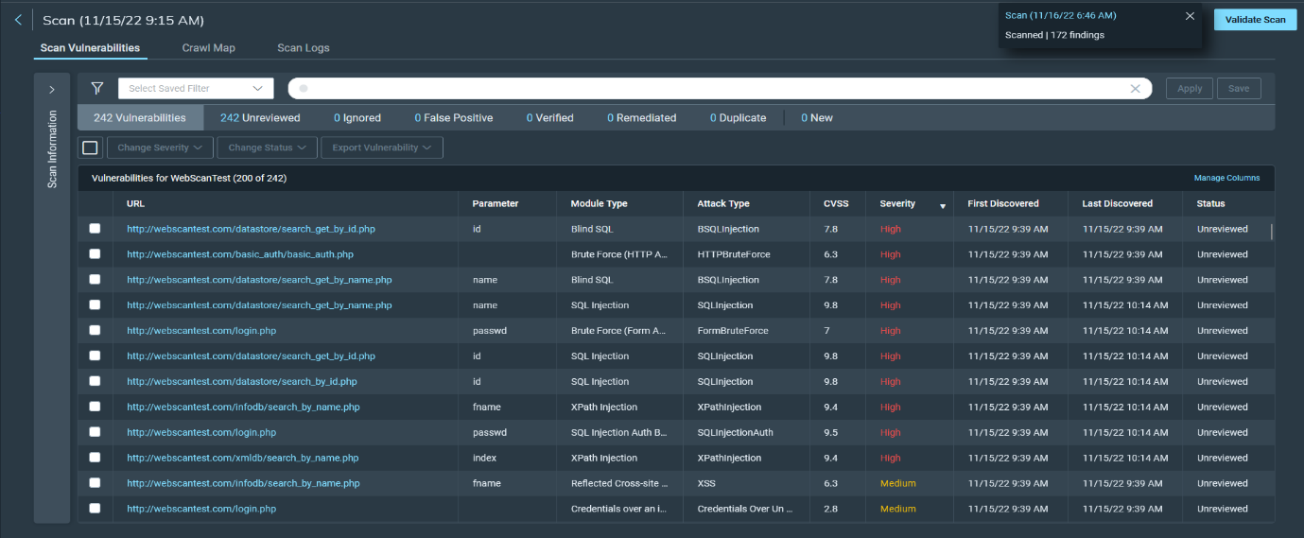

Here we can see every vulnerability found in the WebScantest website.

Clicking on a vulnerability shows the details of the vulnerability

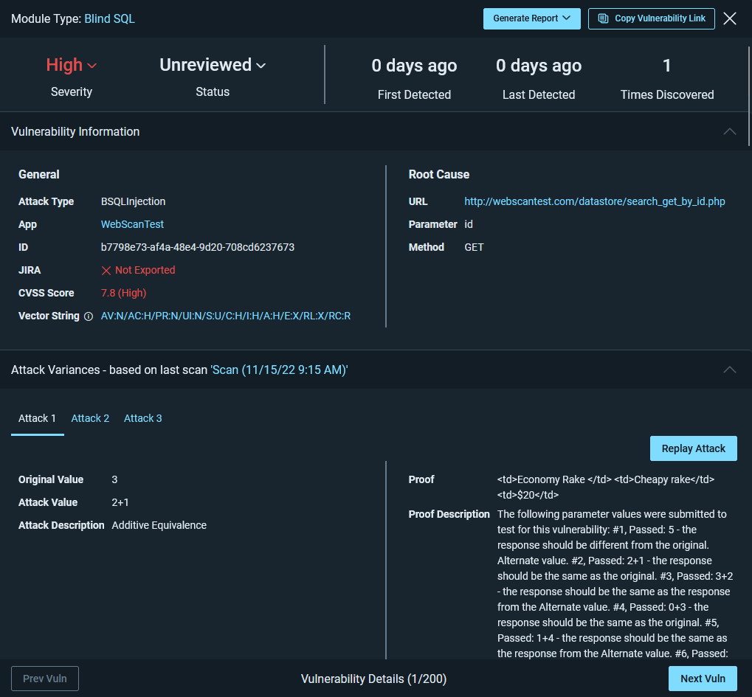

I clicked on first vulnerability and we can see the details of the “Blind SQL Injection” Vulnerability having CVSS rating of 7.8, also with the root cause “website url”.

To export the vulnerability report, click on generate report button to get the report in pdf or docx format.

In the pdf file we can see the detailed report of vulnerability with the remediation process.

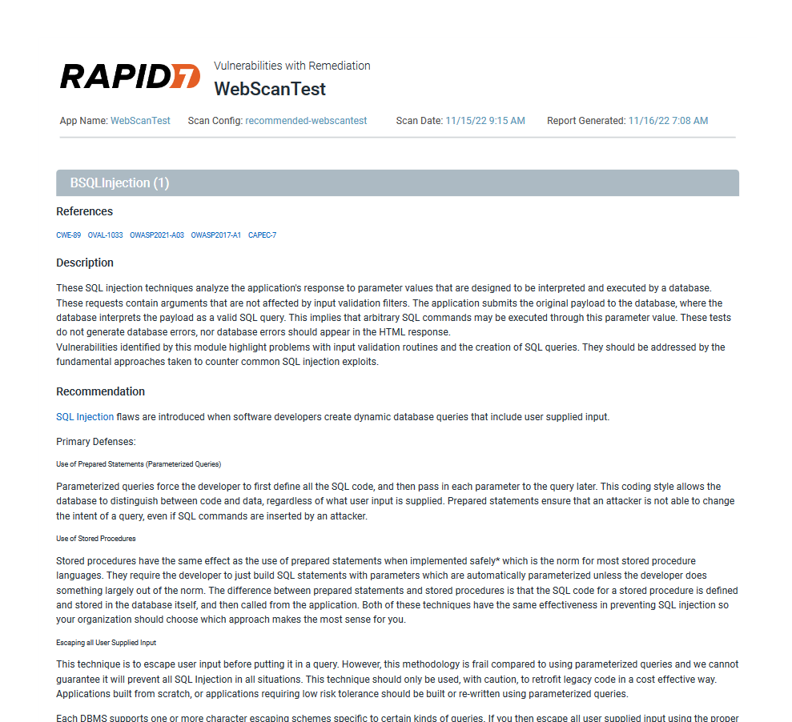

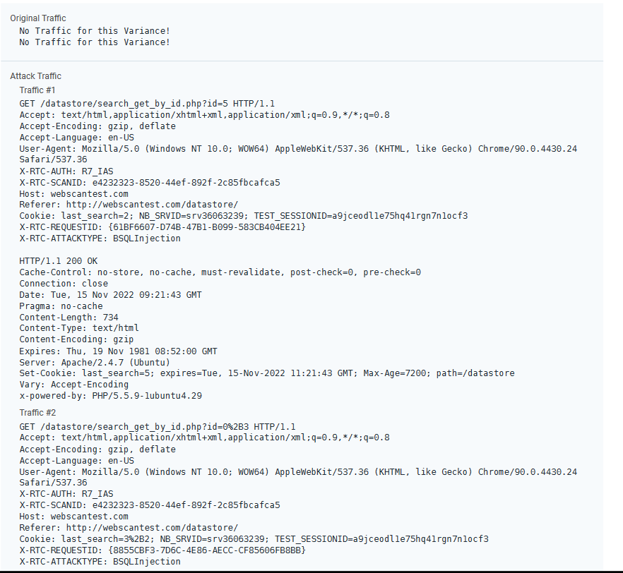

We can also get a peak on what is happening behind the scenes of the attack and the methodology behind the attack.

**Conclusion**

Rapid7 insightAppSec Vulnerability Scanner is very helpful in finding and getting remediation steps on vulnerabilities. We can schedule scans in the scheduling option in the platform.